SusGov

Driving sustainable governance and decision making of corporate entities

Welcome to our submission for the creation of a system for sustainable governance of corporate entities. The project proposes a system that would solve two problems and potentially many others. The first problem is what we call Phoenix AIs. A Phoenix AI is a company where an AI sets up a company, transfers assets and/or incurs debt, and winds up the company within days, and potentially seconds. This pattern can be repeated an infintium. Such a pattern of behaviour leaves creditors and others including taxation authorities out of pocket. Also it can be used to facilitate criminal activity, ie the rapid movement of money and other assets from entity to entity. While this may appear to be a potential future problem, it is a current outlier as there are instances of it occurring and will only increase as AIs become more prevalent.

Second, is the broader issue of encouraging corporations make decisions that benefit society instead of harming it. Corporations often make decisions that maximise profits and favour short term thinking over long term consequences. By using radical transparency corporations’ decisions can be subjected to public scrutiny, both by humans and AI and the scrutiny can drive behaviour that is good for society.

With more and more official and government systems being digitised and available programmatically, it is increasingly important to have systems of accountability, smart monitoring and evolving patterns recognition to identify whether the impacts on society are operating as expected, and when outliers emerge to identify and remediate them.

Blockchain underpins the project by providing an immutable ledger of information that is publicly available. Traditionally companies have kept information which has not always been accurate, ie it has not been recorded, or even if it has been recorded, changes are made to it to hide wrongdoing. Sometimes the changes can be detected, but that requires much work and time.

We may unintentionally in the process of trying to detect and mitigate Phoenix AI corporate behaviours create over time a system that trains Phoenix AIs to operate as legitimate sustainable businesses, which would be an interesting outcome.

# Conceptual Design

This conceptual design is about using a combination of technologies to create more sustainable behaviours in corporates with radical transparency through an immutable record of key corporate/business decisions in the life cycle of a company. This would support the identification of evolving patterns of what constitutes healthy, legitimate, accountable and sustainable businesses and decisions, versus the current system that encourages unsustainable decision making through short termism. Phoenix AIs are an example of Decentralised Autonomous Organisations (DAOs) that can create a company, transfer money and close down the business, effectively transferring money for often criminal purposes without detection. A system of surfacing key life cycle decisions of businesses in a more linked way might help detect and remediate gamable systems.

Radical transparency allows the entire society (certainly many players within it) to play a part in driving more sustainable corporate decisions, whether it is by supporting consumers to choose better products or services that align with their ideals, or to better detect and disrupt autonomous systems that abuse loopholes for financial gain. In this way, it is a proposal to support a greater role in regulation for all of society rather than leaving regulation to siloed regulatory agencies.

Below is a quick diagram of the problem created by Phoenix AIs compared to Phoenix schemes, compared also to a pattern of a legitimate business. The Phoenix AIs can operate so much faster than the human systems of detection and remediation that assume human perpetrators:

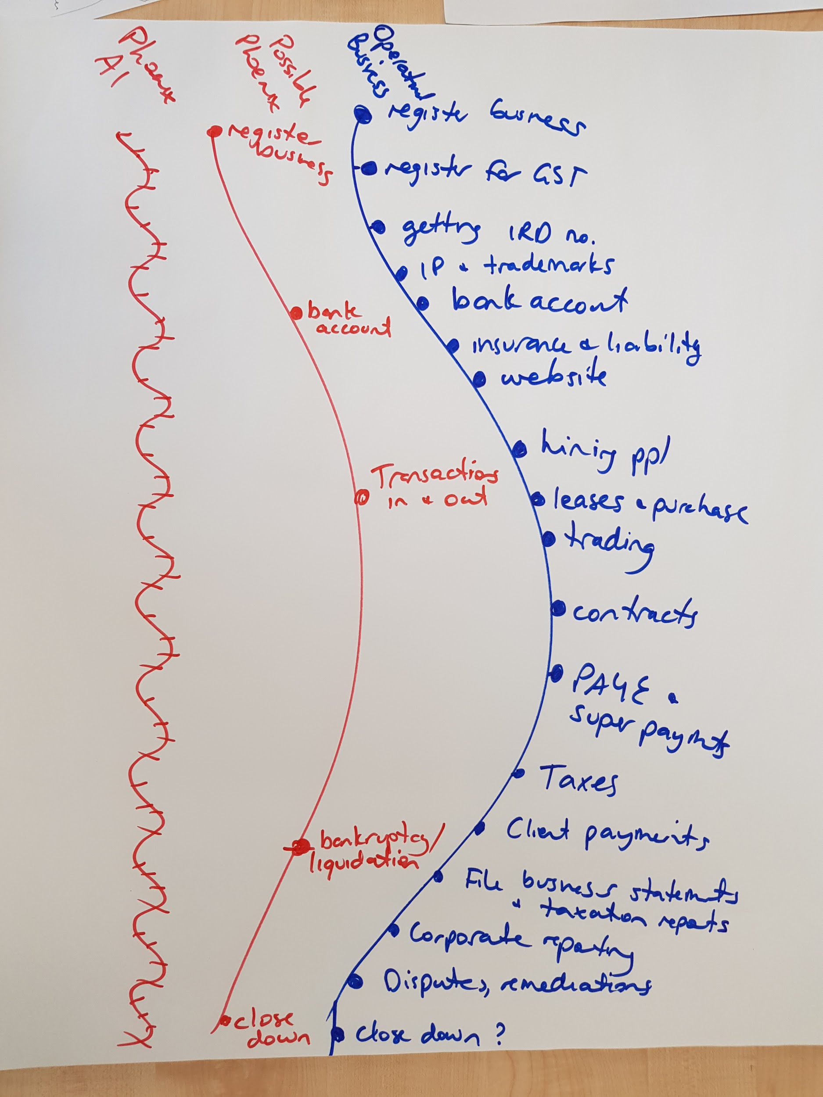

We anticipate three aspects to the concept:

1. Data and rules - the publicly available data regarding business activities (formal and informal including everything from business and director registrars and transactional records through to social media activity and human presence) combined with the business rules they operate within (regulation and compliance, HR requirements, bankruptcy rules).
2. The SusGov system which has two parts:
   1. Recording of key corporate decisions on an immutable ledger as mapped and sourced from public data and expected behaviour from rules (blockchain, machine learning, automated data sourcing, symantec analysis, modelling). AI can identify when changes are made to source materials compared to the immutable ledger which might raise questions, for instance why is the same director named in 43 companies that each started up, transferred money and shut down within days? Perhaps it is a case of stolen identity or a vulnerable person being used.
   2. Pattern recognition and monitoring of unique corporate identities to see outlier or unexpected behaviour, with notifications or real time remediations for accountability where possible, to close systemic loops for bad behaviour, and for identification of and actioning on Decentralised Autonomous Organisation bots/software.
3. The systems that would use SusGov for improved self-governance and self-determination:
   1. **Detection and prevention** - as “bad” behaviour is surfaced, various actors can play their part, whether it be customers moving their business elsewhere through to regulators or people in charge of parts of the system clearly being taken advantage of. Automated systems such as phoenix AIs would be more easily detected, disrupted and relevant loopholes closed with players responsible for the different parts of the systems motivated through transparency of accountability (eg, a business registration process that is too simple for an AI to game without detection).
   2. **Traceability** **and modeling** - by recording major corporate decisions and invoking in the smart contracts the rules drawn upon in real time, we create traceability of behaviours and decisions, and can go on to correlate how rules or changes to rules impact the system around them.
   3. **Corporate behavioural shift** - traceability of decisions would drive better and more sustainable decisions of persistent, legitimate corporates (especially in the case of more broad use of personal AI and modelling tools to project impact), but this behavioural nudging would likely have no impact on transitory, illegitimate corporates such as phoenix schemes or phoenix AIs.

See below for the conceptual model: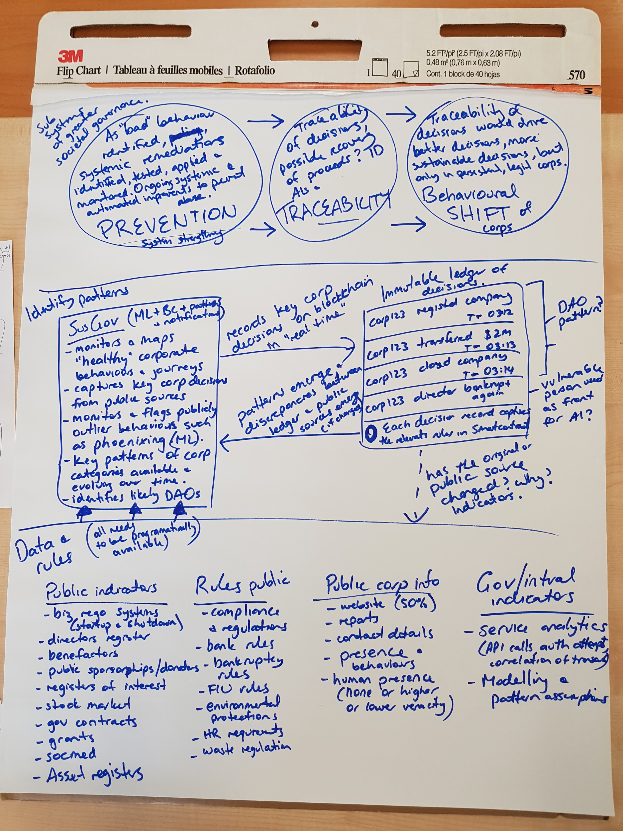

# Design Specifications

## Overview of the governance system design and architecture

1. A mapping (including semantics and ontological) of public data and rules regarding corporate behaviours which grows over time using spidering tools and machine learning.
2. A mapping of corporate entities with unique identifiers (likely NZBN) with recording of key business decisions as they occur and related rules captured by smart contracts on blockchain.
3. Patterns recognition system and patterns library to match behaviours back to common AIs, organisations or humans.
4. Sustainability modeling based on societal indicators (perhaps the new higher living standards?) including sustainability corporate behavioural models to compare against actual behaviours.
5. Notifications system for outliers, DAOs and unsustainable behaviours. Subscription services for other entities in the public sphere to opt into areas of interest or action.

## The basis of the governance process

The basis of this governance process is radical transparency to drive corporate behaviours and to surface unsustainable behaviours, decisions or points of weakness in the broader systems. It creates public infrastructure for driving better decision making and through transparency, gives all societal actors the tools to address or redress bad corporate behaviours through myriad ways.

The key idea here is that any single entity trying to tackle this issue (or any issue) is limited to the resources of that entity and thus unable to scale in response to exponential growth. This is compounded where machines can autonomously game human systems with negative impact on human society. So opening up the detection, prevention, traceability and remediations to the public eye may create a more exponential response to exponential systems.

## System features

A Phoenix AI can be relatively easily identified if it sets up a company and winds it up within a week or a day or less. If Phoenix AIs are programmed to take account of this and there is a sizable time between setting up the company and winding it up, for example, if legislation states that a company must exist for a certain period of time, there is the real possibility of Phoenix AIs not being detected. To counter this pattern recognition is required.

A legitimate business goes through a life cycle which is harder for an AI to replicated [in the short to medium term at least]. For the purposes of this project a company has been used as the protections of limited liability is attractive for Phoenix AIs. The life cycle of a New Zealand company includes:

* In New Zealand the person creating the company needs to have a RealMe login [RealMe logins are mediated by the New Zealand government, but they are relatively easy to set up and sometimes “vulnerable people” can be coerced or tricked into providing their details for the RealMe login. Thus even if the RealMe process was tightened up it is relatively easy for a human to be co-opted to set the business up].
* When the application to register a company is made need to have a company name and need at least one human to be director and need shareholders, again humans, to be registered.
* Lodge constitution – but common for companies not to have one.
* Register for GST – but only if earning more than $60,000 per year. (Can register for GST and company at the same time)
* Get IRD number for the company – but don’t have to have one
* Required to disclose if there is an ultimate holding company (UHC) – but this isn’t checked
* Set up bank account(s)
* Set up website (noting that half of New Zealand companies don’t have websites)
* Hire people – but not everyone does this, ie self employed and/or increasing use of contractors (such as Uber)
* Pay employees
* Pay PAYE (Paye as you go tax, ie the employer pays the employee’s income tax on behalf)
* Enter into leases and purchase goods and services
* Enter into contracts including insurance contracts, pay and receive money
* Accounts need to be filed with the Companies Office
* Company is wound up

The failure to do one or a few of the above does not mean that a company is a Phoenix AI. Rather patterns can be detected. For example, if the same person is a director of many different companies, none are registered for GST, and none have bank account numbers this raises a red flag.

While much of the information is available, not all of it is available publically, for example, the non-payment of employee’s wages (a sign that a company is experiencing financial difficulties). SusGov would further enable myriad entities to act when combining corporate decisions and behaviours with their own information. For instance, regarding non payment of wages to employees, it is unreasonable to expect employees to always be whistleblowers as employees quite rightly fear retribution from employers and often do not know their rights. The Inland Revenue Department receives information about employee’s wages and is able to detect and act if employees are not paid in time.

There is also the possibility of dealing with the issue that an AI may generate myriad “identities” throughout its operation, but any repeatable patterns of the AI become a fingerprint of sorts which is detectable through machine learning and analytics, helping pinpoint the source of certain behaviours.

## Why this governance process?

We chose this process because we think transparency is an effective mechanism to both surface issues and to nudge or mitigate behaviours, as noted above. Both of the corporate entities themselves, but also the gatekeepers to the business rules and systems which a business interacts with (such as registering a business). The traceability and immutability of blockchain assists in creating this linked and immutable transparency of business behaviours already in the public domain, and creates new opportunities for monitoring and audit by myriad players.

## Process governance and enforcement

Interestingly, existing rules, legislation and enforcement powers granted to the state would be complemented by new levers of naturally motivated players in the system. A competitor is motivated to notice if a company is doing the wrong thing, but also accountable if they themselves do the wrong thing. There would need to be greater legislative pressure on governments to make more information public which would have impacts on various pieces of legislation, however some of this concept could be done immediately within existing legal and enforcement frameworks.